

Dr. Theodore, Edwards inc.
2017-09-30
Dr. Edwards
9284 Randy Rapids Suite 029, Smithberg, UT 21861
Phone: 9000149940
Fax: 6032282146

Re: Pam, Lawrence
PHN: 7040958573
Birthdate: 15-Dec-1963
Address: 61313 Pham Summit Apt. 315, Lake Katie, TN 55983
Patient number: 3170431639

To Whom It May Concern:

This is a medical letter to state the above patient is pregnant with expected delivery date of 03-Feb-2025. Hoping this information is satisfactory for your requirements.

Thank you.

Sincerely,
Dr. Theodore, Edwards
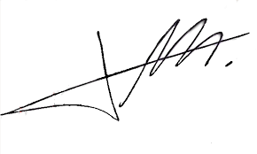
FRCS© NCMP
Clinical Assistant Professor, UBC
Department of Obstetrics and Gynecology SMH

